4002-XXX
Software Development on Linux Systems
Lab 03 – Setting up the Linux environment, intro to command line and package installation

Name: ______________________________________ Section: _____________

NOTE: This is a long lab, it is recommended you start early. The Linux environments you set up in this lab will be used through the rest of the quarter. You will need to complete these in order to work on labs in the future. You should strive to get the first two activities done within lab.

Activity – Configuring Ubuntu
After you have installed Ubuntu, you will need to configure the system and install a variety of packages. You will be introduced to the basics of Ubuntu and Linux.
1) Installing Updates
a) From the application menu, choose “Update Manager”
b) Hit check
c) After the package list has been retrieved, hit “Install Updates”
d) Wait for updates to install and hit “close”
e) Restart the machine if you have to
2) Installing Software
Ubuntu uses the Debian packaging system (dpkg). Installable files come in .deb packages. Though Linux distributions can install packages in a variety of formats and it is common to install from source code, most packages will be found in .deb files as it automatically configures and installs the software. After a .deb file is installed all updates to that software will be automated through the update manager.
Dpkg is the Debian packaging system, but the front-end for this system is APT (Advanced Package Tool). For most of the software you install on Ubuntu, you will use APT or some version of APT. Ubuntu provides a graphical tool for APT called “Ubuntu Software Center”.
You will also find that Ubuntu allows you to install a much more technical version of the software center called “Synaptic Package Manager”
a) Installing Software using the Ubuntu Software Center
We will be installing Chromium. This is the open source project in which Google Chrome is built on. Firefox, another open source project, is provided with most Linux distributions by default.
I) Open Ubuntu Software Center
II) In the search bar, type in “Chromium” and hit enter.
III) In the results for Chromium you will be presented with the option to get more info or install. Choose more info.
IV) Here you will find information about the package and user reviews. Choose “install”
V) Inter your password and hit “install”
VI) Wait for chromium to install. While it installs, you may go back and explore other software within the software center.
VII) After Chromium is installed, you may close the software center
VIII) Open Chromium from the applications menu in Ubuntu

Instructor/TA Sign-Off _______________________________
b) Installing software from the command line with APT
We will be installing GIMP (GNU Image Manipulation Program). This is somewhat similar to Adobe Photoshop and a variety of other tools, but GIMP is used to create the actual desktop on most Linux distributions, as the GIMP Tool Kit (GTK+).
Explanation of Sudo: Ubuntu does not directly allow users access to the root account (the administrative user). Instead a regular user may choose to use “sudo”. By using sudo you run your individual command/software as the root user with the use of your password. Though you are the administrator, you may only run individual commands as the administrative level by using sudo. This increases security preventing anyone with access to your account to do or install anything without your password.
I) From the applications menu, open “Terminal”
(Alternatively, hit ALT and F2, and type “gnome-terminal”; then hit enter)
II) Type “sudo apt-get install gimp”
III) Type in your password to run the command at an administrator level
IV) When asked to install, choose Y and hit enter
V) After the install finishes, type “exit” and hit enter
VI) Open GIMP from the applications menu in Ubuntu
Explanation of apt-get command
Explanation | Admin  command | Apt download  tool | Apt command for installation | List of packages to install
Command | sudo | apt-get | install | Gimp chromium
Instructor/TA Sign-Off _______________________________
Activity – Configuring Fedora
After you have installed Fedora, you will need to configure the system and install a variety of packages.
1) Installing Updates
a) From the application menu, choose “Software Update”
b) Hit “Install Updates”
c) Wait for updates to install and hit “close”
d) Restart the machine if you have to
2) Installing Software
Fedora uses the RPM Package Manager (RPM, a recursive acronym). Installable files come in .rpm packages. Similarly to Ubuntu, Fedora and other Linux distributions are not limited to just their type of package format. The RPM format will be the most common format for Fedora as it automatically configures and installs the software. After a .rpm file is installed, all the updates to that software will be automated through the update manager.
RPM is the Fedora packaging system, but the front-end for this system is YUM (Yellowdog Updater, Modified). For most of the software you install on Fedora, you will use YUM or some version of YUM. Fedora provides a graphical tool for YUM called “Add/Remove Software”.
a) Installing Software using Add/Remove Software
We will be installing Filezilla and VLC
I) Open Add/Remove Software
II) In the search bar type in “Filezilla” and hit find
III) Put a check in the checkbox next to the Filezilla result
IV) Hit the “apply” button
V) When the additional confirmation screen comes up, hit “continue”
VI) Type in the root user's password and hit “enter” to confirm the install
VII) Wait the application to install, then close add/remove software
VIII) Open Filezilla from applications menu in Fedora

Instructor/TA Sign-Off _______________________________
b) Installing Software from the command line using YUM
We will be installing Wine (Wine is not an emulator, a recursive emulator). Wine is an open source application library that allows Linux to run Windows software. This allows Linux users to run Windows software, such as World of Warcraft or other games/software.
Explanation of Su: Fedora runs users as unprivileged users similar to Ubuntu, but to perform administrative tasks you will temporarily login to root. It is also possible to use sudo, but sudo is not configured for the user by default. Su allows you to login as root using the root password. Once you are root, you are the administrative user.
I) From the applications menu, open “Terminal”
(Alternatively, hit ALT and F2, and type “gnome-terminal”; then hit enter)
II) Type “su -”
III) Type in the root password to login to root
IV) Type “yum install wine”
V) When asked to install, type “y” and hit enter
VI) After the install finishes, type “exit” and hit enter to return to a regular user instead of root.
VII) Type “exit” and hit enter to close terminal
VIII) Open Wine Configuration from the applications menu in Fedora
Explanation of su -
Explanation | Command to switch user | Hyphen means to load the environment settings of the new user | Username (optional)  Allows you to change to the specified username instead of root
Command | su | - | userjane

Explanation of yum

Explanation | RPM download tool | Yum command for installation | List of packages to install
Command | Yum | Install | Wine filezilla firefox

Instructor/TA Sign-Off _______________________________
Activity – Introduction to the Linux File System
For the lab write up, look up the Linux file system layout and describe each of the top level directories. Explain what these directories are typically used for and explain the types of files (manual, configuration files, user files, etc) you would expect to see in these directories.
Use http://linuxreviews.org/beginner/ as a reference
/ (forward slash/root directory) - The root directory is the top level directory in Linux, all files and folders are under this one. The root directory and the root user are not related. The root user is the administrator. The root directory is just the top folder of the file system.
​/boot - Boot contains all of the data and files for starting the operating system. This is where the Linux kernel and operating system boot loader are contained.
/etc -
/bin -

/sbin -

/usr -

/lib -

/home -

/root -

/var -

/tmp -

/dev -

/mnt -

/media -

/proc -

/lost+found -

Activity – Introduction to the Linux File System Part I
FOR THIS PART YOU MAY USE EITHER UBUNTU OR FEDORA
In this lab, we will look at how to use the Linux command line and the file system
The Linux file system is made of up of files. In fact, everything is a file in Linux. The web cam, the web browser, the network manager and everything else are all files containing runtime data. Programs/Applications are marked as executable files. Any file can be marked executable in Linux.
Directories/Folders are executable files in Linux containing data on the files that belong to them with pointers to their locations on the hard drive.

Let's take a look at where you are -
Note: For any commands, do not type the quotes unless specified.
In Unix, all commands and file names are CASE-SENSITIVE
1) Open “terminal” from the applications.
2) Type “cd / “ and hit enter. (cd changes your current folder to the specified folder)
3) Type “ls” and hit enter (ls lists the files of the current or specified directory)
You will see something somewhat similar to this, depending on if you used Ubuntu or Fedora
4) Type “pwd” (pwd shows the current location – path to working directory)

You will see a / if you ran the command correctly. This is the root directory. It is the top folder of the file system. All folders exist under this.
5) Type “cd /home” and hit enter
6) Type “ls -l” and hit enter. (That is a lowercase L, not a one. The -l provides a list view)

7) /home is the folder in which user's store their personal data and files.
Cd to the folder you see in /home. This is probably your-lastname-user
8) Use pwd to ensure you are in the your home directory. This should be
/home/yourlastname-user/
9) ~ is a shortcut to your home directory
Type “cd ~” and hit enter to go to your home folder any time you want to.
10) In your home directory you will make a folder manually called test
Ensure you are in your home folder.
Type “mkdir test” and hit enter
11) Type “ls” and hit enter to ensure you have created the folder
12) To create a new file use the touch command. This creates an empty file.
In your home directory type “touch testfile” and hit enter
Type “ls” and hit enter to ensure you have made the file
13) To copy a file, use the cp command
cp original-file-name new-file-name
In your home directory type “cp testfile testfile2”
Type “ls” and hit enter to ensure you have made the file
14) To remove a file use the rm command
In your home directory, remove the testfile2 you just made
Type “rm testfile2” and hit enter
Use ls to ensure you deleted the file
15) In unix, there are several symbols for directories
A double period (..) means the directory above you
A single period (.) means the current directory
A forward slash (/) means a different directory
Copy the testfile into the test directory
In your home folder, type “cp testfile /test/testfile” and hit enter
Type “ls” to ensure that the testfile is still in your home directory
Type “cd test” to change to the test directory
Type “ls” in the test directory and ensure a copy of the testfile is there.
Type “cd ..” to move up a directory back into your home directory
Type “pwd” or “ls” to ensure you are back in your home directory
16) To rename a file or move a file we use the command mv
mv current-file-name new-file-name (this renames a file)
mv current-file-name /different-folder/current-file-name (this moves a file to a another folder)
Change directory to the test directory
In your home directory type “cd test” and hit enter
Type “pwd” and hit enter to ensure you are in the test directory
Type “ls” to show the current files in the test directory
Type “mv testfile newtestfile” and hit enter to rename the file
Type “ls” to show the current files in the test directory. This file should now be renamed.
17) Change directory to your home directory : “cd ~”
Create a directory called newtestdir with “mkdir newtestdir”
Use ls to ensure the directory has been made
To remove a directory, use rmdir
rmdir directory-to-remove (This can only be done to an empty directory. There is another way to delete directories that are not empty)
Type “rmdir newtestdir” and hit enter
Use ls to ensure the directory is not longer there

Activity – Introduction to the Linux File System Part II
Using the commands from the previous activity, you will need to create a directory structure.
Go to your home directory “cd ~”
Remember in Unix, all commands and filenames are CASE-SENSITIVE
Write down all of the steps you used to make these files/directories in order to get credit
1) Create three directories within your home directory.
Name them “apartment1” “apartment2” and “apartment3”
2) Inside of the apartment1 directory create three files
Name them “ronny” “bonny” and “clyde”
3) Inside of the apartment2 directory create two files
Name them “barry” and “jerry”
4) You will need to make a clone of barry, copy him to to the apartment1 directory
5) Turns out bonny and clyde want to move in together
Move (don't copy) bonny and clyde to the apartment3 directory
6) Someone is getting a name change. Change ronny to ronald in apartment1
7) The residents in apartment2 are moving out. Remove barry and jerry from apartment2
8) We are going to demolish apartment2. Remove apartment2
Hand in your written steps/commands as part of the lab report to get credit for this activity
Activity – Introduction to the Linux File System Part III
You will now use permissions in Unix. You may recall this from previous classes using the Unix file system. Permissions are what allow access to users.
If you use the command “ls -l” from earlier [That is a lower case L, not a one], you will see the files and permissions in a directory.

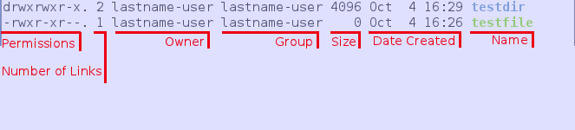
The permissions on testdir directory are drwx rwx r-x
The permissions on the testfile file are -rwx r-x r--
The d in the beginning means it is a directory. The testfile does not have a d because it is not a directory, it is a file.
After the d the permissions are grouped into three categories. Owner – Group – Other
You will see that the 2nd through 4th characters in the permissions for both files are
r w x – This means read write and execute.
NOTE: Directories need execute permission in order to be opened. If someone does not have execute permissions to a folder, they will not be able to go into that folder.
In Unix, permissions have corresponding numbers.
Read – 4
Write – 2
Execute – 1
These add together to get the total permissions
Read + Write + Execute = 4 + 2 +1 = 7
Read + Write = 4 + 2 = 6
Read + Execute = 4 + 1 = 5
You can change permissions with chmod and the number
Example: chmod 755 filediff1
This would give the owner rwx, and the group/others with read and execute.
These are some of the more common permissions.
755 – Owner has read, write, execute, while others have read and execute
744 – Owner has read, write, execute, while others have read
644 – Owner has read, write, while others have read
Setting a 6 to your own file prevents any software you are running from executing that particular file. This is a security precaution for files that could be used maliciously.
Go to your home directory “cd ~”
Remember in Unix, all commands and filenames are CASE-SENSITIVE
Write down all of the steps you used to make these files/directories in order to get credit
1) In the “apartment1” folder change the file “ronald” to have the permission 755
Change the file “bonny” to have the permissions 744
Change the file “clyde” to have the permissions 644
Change the file “barry” to have read and write permissions, but not execute
Hand in your written steps/commands as part of the lab report to get credit for this activity
Activity – Introduction to the Command Line
We will be looking at Linux commands and the extensive abilities of the command line. In Linux, most things can be done from the command line including watching movies, playing music, browsing the internet, downloading files, editing files, etc. In Linux, most things are broken apart into individual components that have been constructed well and can be used on their own. Newer components often implement these into their own solution which can be used on its own. For example, FFMpeg is an open source library that has been extensively by developers within their own solutions, however, FFMpeg itself is made up of a number of libraries and components. Those libraries and components are made of dozens of components themselves.
1) In Unix, the command “man” is the command for manuals. This is where you can find out more about a command.
Open “terminal” from the applications menu
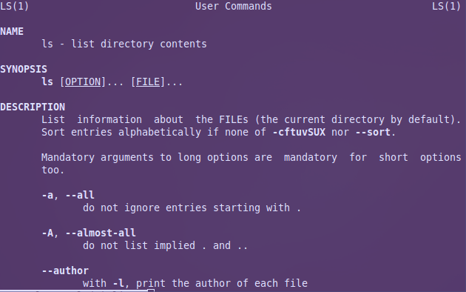
Type “man ls” and hit enter

[you can use the up and down arrows to read]
Type q to quit the manual
2) In terminal, type “man diff” and hit enter
Read how to use the command diff
Take a screenshot of the manual for the report
Type q to quit the manual

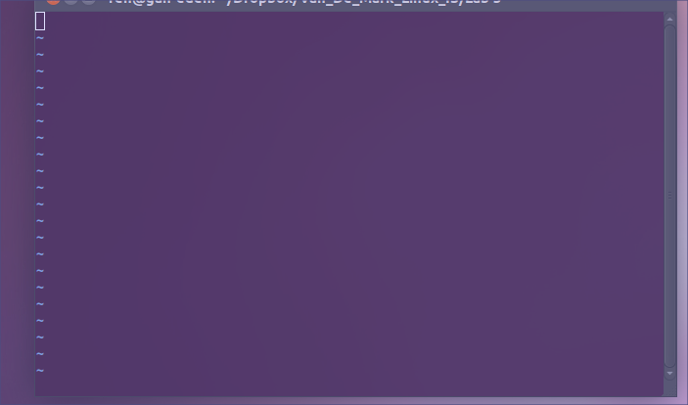
3) You will now create two files using vi
In terminal go to your home folder
Type “vi filediff1” and hit enter
Type “a” [this enables editing mode]
Type “line1” and hit enter
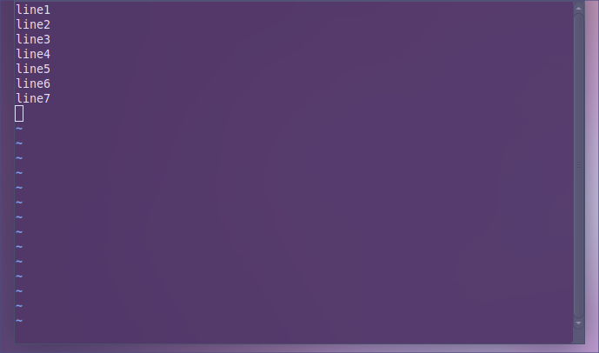
Continue until you have typed line7 like below
Hit “esc” [this disables editing mode]
Hold “shift” and hit “;” (semicolon) [this enables the options]
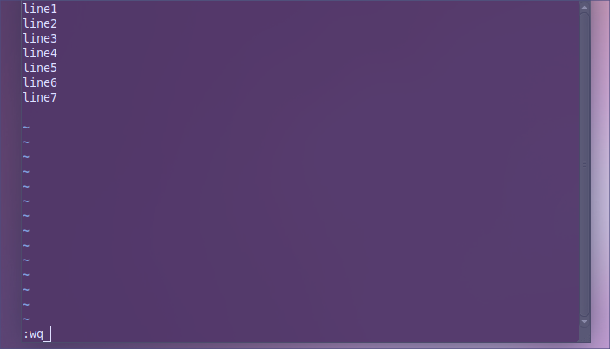
Type “wq” and hit enter [this means write & quit, q! means quit w/o saving]
You now have a file called filediff1 with line1 through line7 in it
4) In terminal go to your home folder
Type “vi filediff2” and hit enter
Type “a” [this enables editing mode]
Type “line1” and hit enter
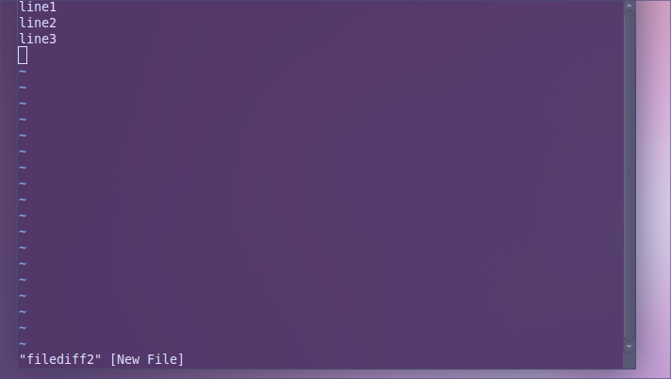
Continue until you have typed line3 like below
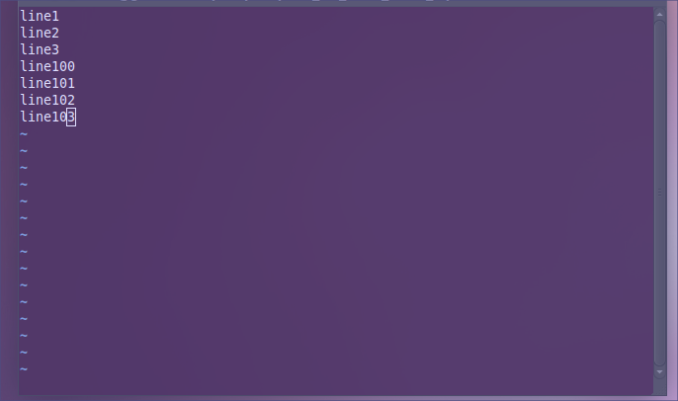
Type “line100” and hit enter
Continue until you have typed line103 like below
Hit “esc” [this disables editing mode]
Hold “shift” and hit “;” (semicolon) [this enables the options]
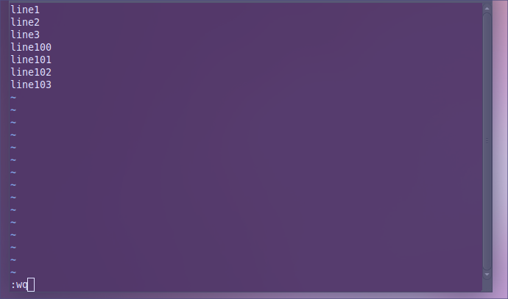
Type “wq” and hit enter [this means write & quit, q! means quit w/o saving]

You now have a file called filediff2 with line1 through line3 & line100 through line103

3) You will use the diff command to compare two files
diff shows you the differences between two files
Type “diff -y filediff1 filediff2” and hit enter
Take a screenshot of the results for the report
A vertical line | means that the two lines are different
A left arrow means something exists in the left one that does not in the right
A right arrow means something exists in the right that does not in the left
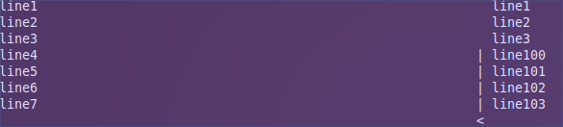
[In this example, a space exists in the left file that does not in the right]
Hint: This command is useful in development if you end up with most than one version of a file.

4) You will cat now cat your files
cat displays the contents of a file
Type “cat filediff1” and hit enter
You can display more than one file at a time
Type “cat filediff1 filediff2” and hit enter
Take a screenshot of the results for the report
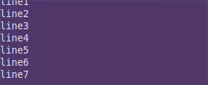
5) Pipe [pipe is the vertical line above the enter button and forward slash] is a command that allows one command to feed into another. This is NOT the same as an AND operation. Pipe takes the results of the previous command and feed it into the next command.
For this example we will use grep, which is a search command
With grep, you search for the term you are looking for.
Here is an example of pipe used to join cat and grep
First cat filediff1
Type “cat filediff1” and hit enter
Next type “cat filediff1 | grep “line3” and hit enter [the pipe is important]

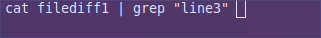

You should now only see line3 because it found it for you
For the lab report, explain what cat did in this command, then explain what the pipe did to the results of the cat command, and finally explain what using grep on line3 did to the results of cat.
6) Pipe can be used with most commands. Find is a command for searching for files. Though find has its own search terms, we can show you how to apply the concepts of pipe.
In terminal, type “find /home/lastname-user/” [this should be the user you created]
Then try 'find /home/lastname-user/ | grep “filediff1”' and hit enter
Take a screenshot of the results for the report

Addendum:

Here are instructions for installing Ubuntu and Fedora if you need them.

Activity – Installing Ubuntu

Ubuntu is a popular distribution of Linux stemming from the Debian family of Linux operating systems.

1) Open Virt-Manager on your host machine
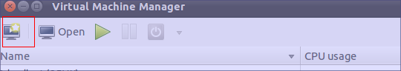
2) Click the play button in top left
3) Name your Ubuntu virtual machine and choose local install media, then click next
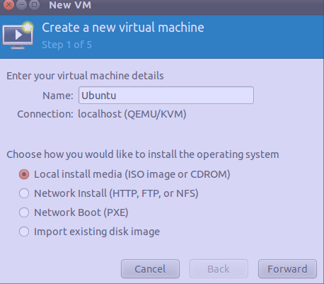

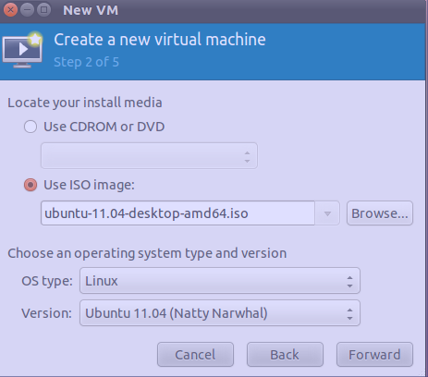
4) Choose your Ubuntu iso image file from the downloads folder in /home/dblab/Downloads
Choose Linux as the OS type and choose the version number that matches the number in the iso file. (IE: “ubuntu-11.04-desktop.iso” would be version “Ubuntu 11.04 (Natty Narwhal)”)

5) For memory choose 1024 MB and 1 CPU
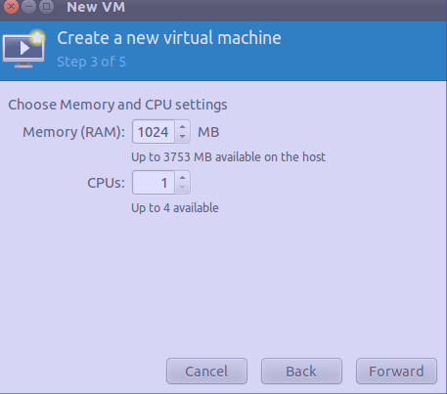

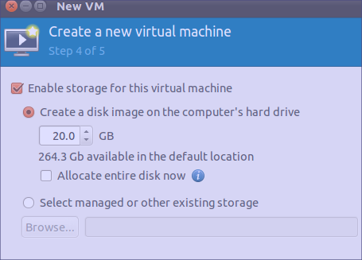
6) Check enable storage for this virtual machine
Create a disk image on the computer's hard drive – 20.0 GB
Uncheck allocate entire disk now
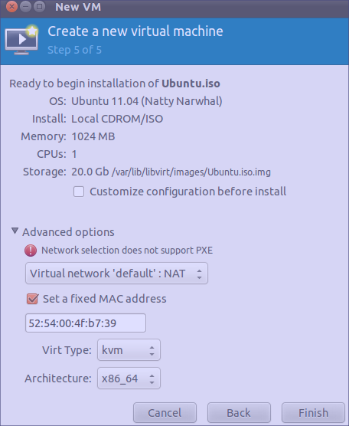
7) After this choose finish

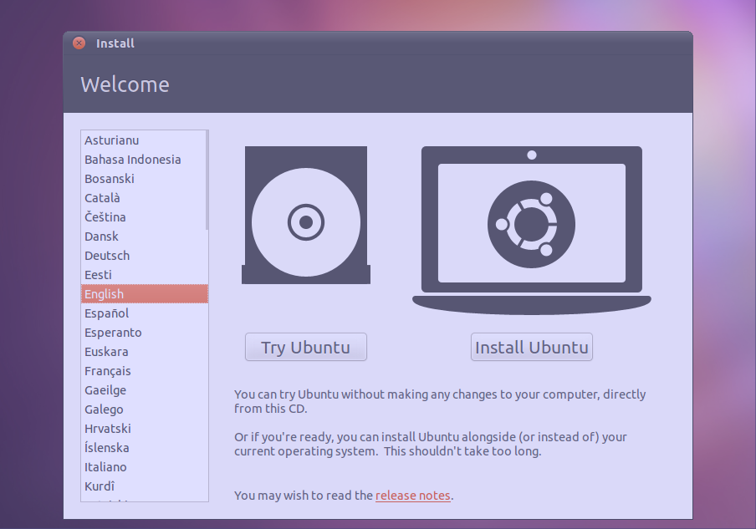
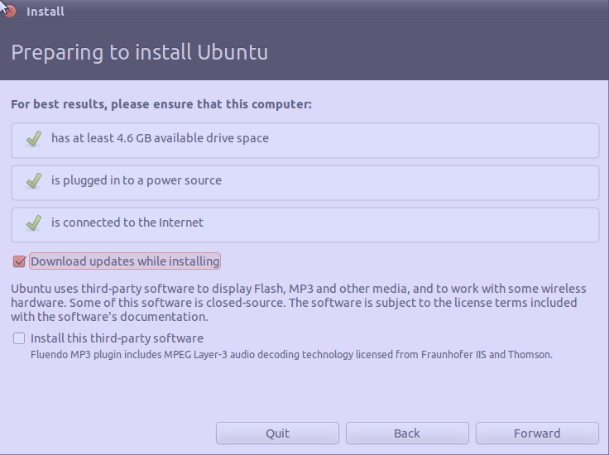
8) Ubuntu will start so that you can install it. At the language screen choose “English” and click install Ubuntu.
9) At the next screen, choose “download updates while installing”
10) Choose something else for allocate drive space
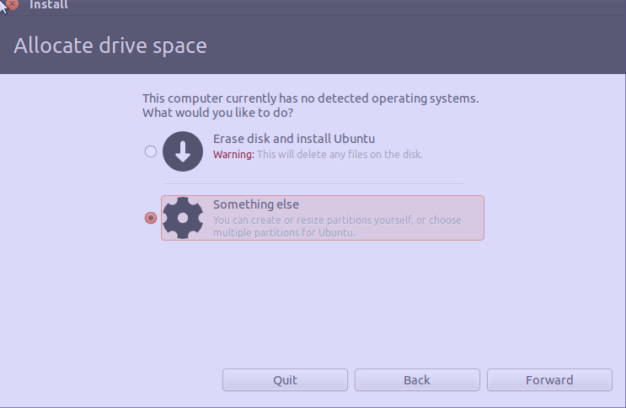

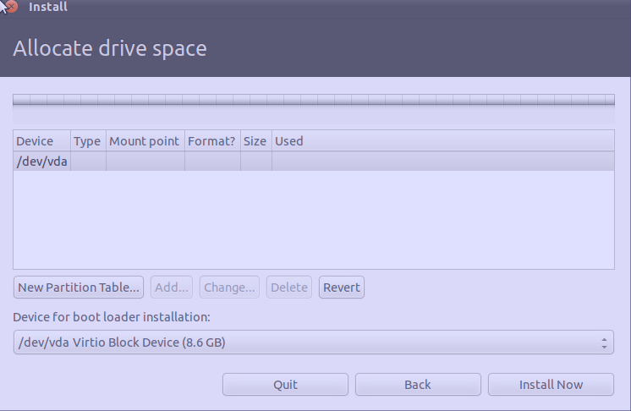
    - Choose the device listed under device and choose new partition table to add free space
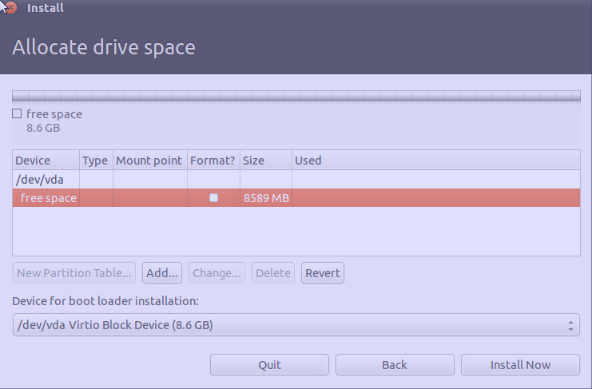
    - After you have made the free space, click on it and choose add
    - Choose Primary partition type
Make the new partition type 500MB
Choose ext4 journaling file system
Choose /mount for the mount point

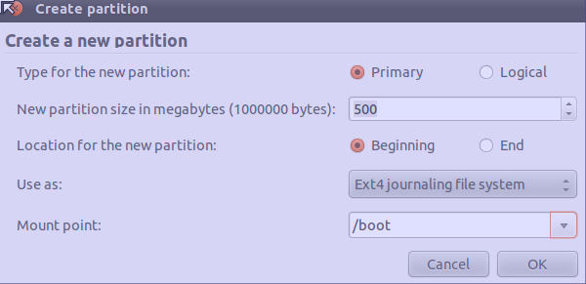

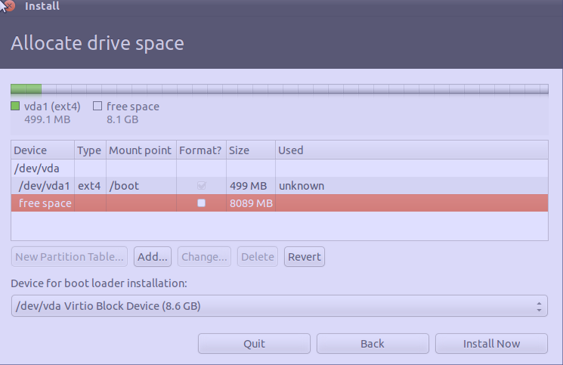
    - Choose free space again and choose add
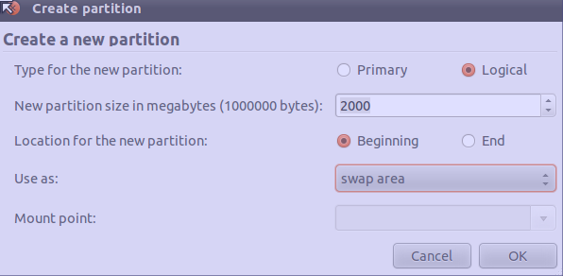
    - Choose Logical partition, 2000 MB and swap area for the type

    - Choose free space again and click add
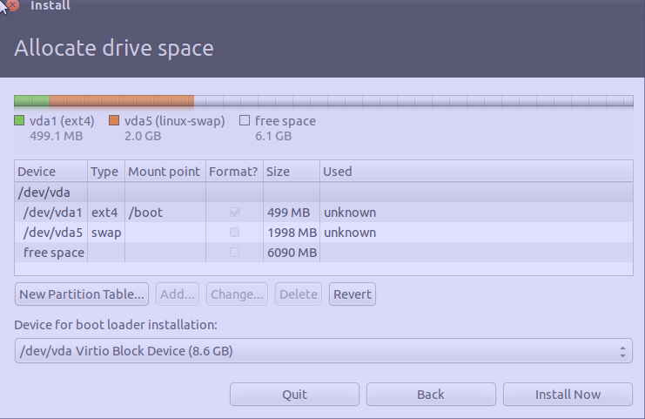

17) Choose logical and make the partition size the largest it can be
Choose ext4 journaling file system for type
Use / as the mount point

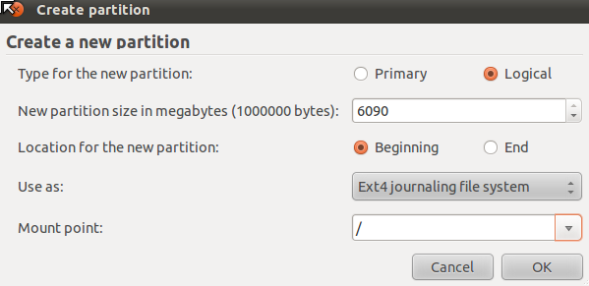

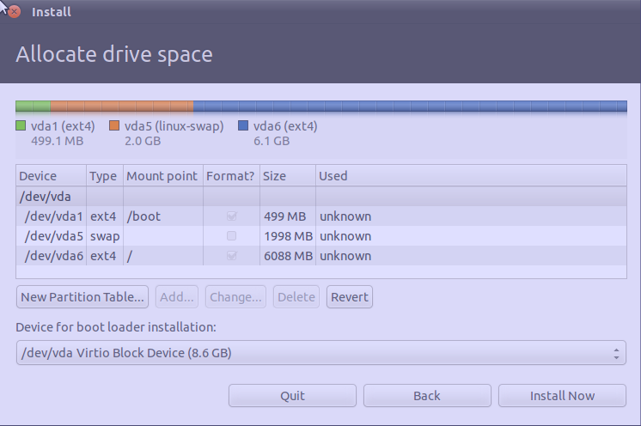
18) Choose install now

19 ) The install will start soon, after a few moments you will be asked to set your location while the system is installing. Choose New York
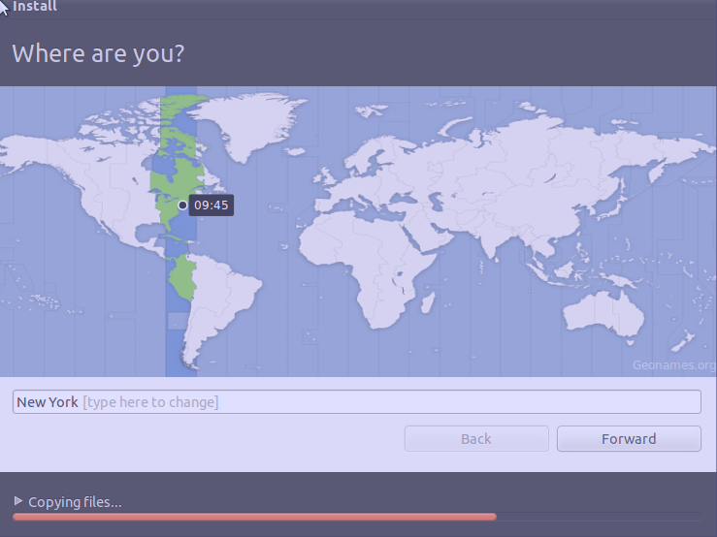

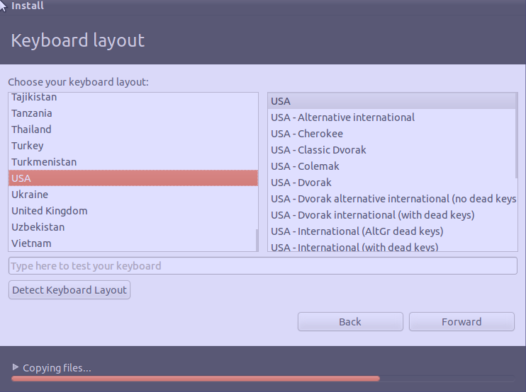
20) For keyboard layout choose USA and USA
21) For your name, choose your last name
For the computer name choose yourlastname-virtual-machine
For your username choose your last name
Choose a password for your machine (YOU MUST REMEMBER THIS)
Do NOT encrypt the home folder
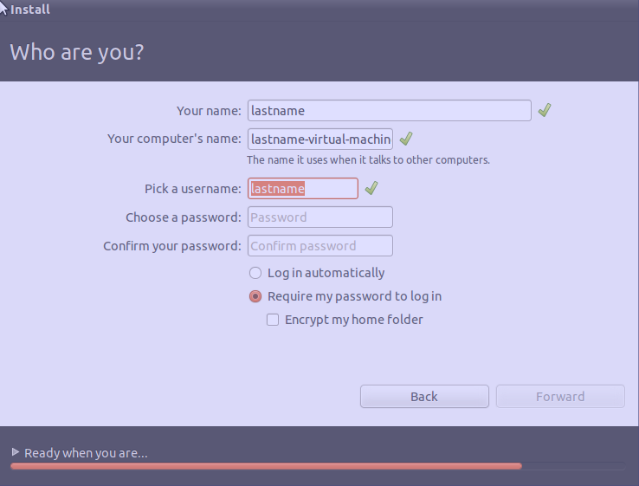

22) Wait for Ubuntu to install. You will need to hit restart when the system finishes

Activity – Installing Fedora

1) Open Virt-Manager on your host machine
2) Click the play button in top left

3) Name your Fedora virtual machine and choose local install media, then click next

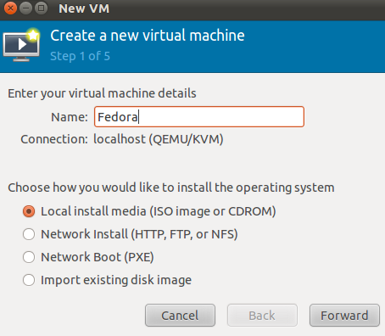

    - Choose your Fedora iso image file from the downloads folder in /home/dblab/Downloads
Choose Linux as the OS type and choose the version number that matches the number in the iso file. (IE: “Fedora-15-x86-_64-DVD.iso” would be version “Fedora 15”)

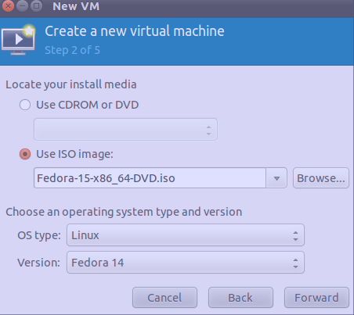

    - For step 3 choose 1024 MB and 1 CPU

6) Check enable storage for this virtual machine
Create a disk image on the computer's hard drive – 20.0 GB
Uncheck allocate entire disk now

7) After choose finish
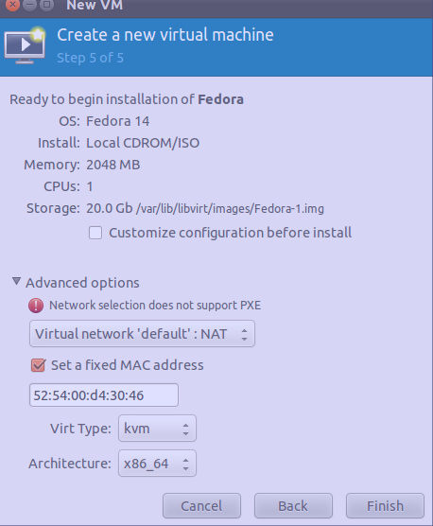

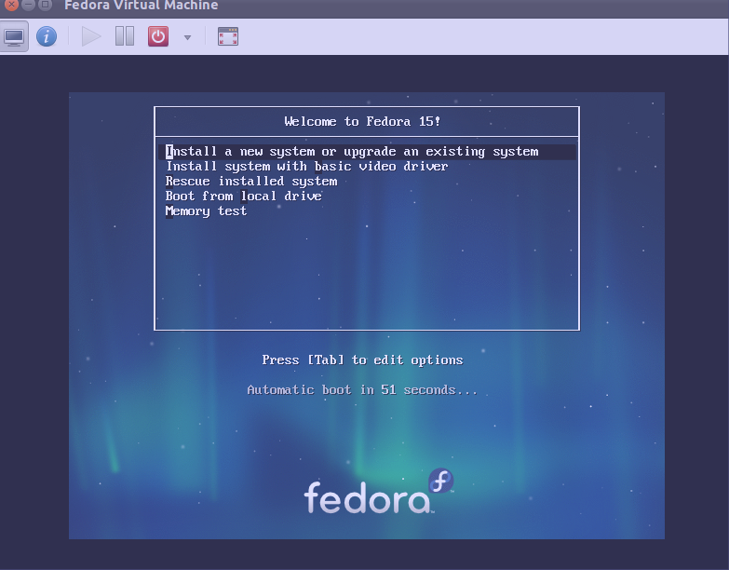
8) At the start screen in Fedora, choose “Install a new system or upgrade an existing system”

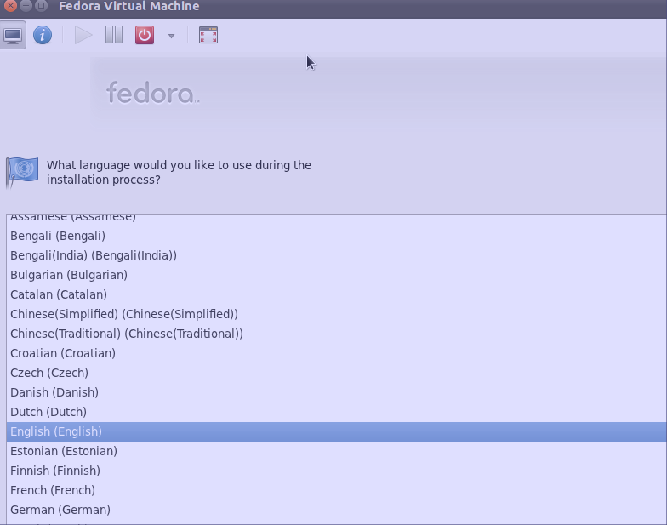
9) For language, choose English

    - For keyboard layout, choose U.S. English
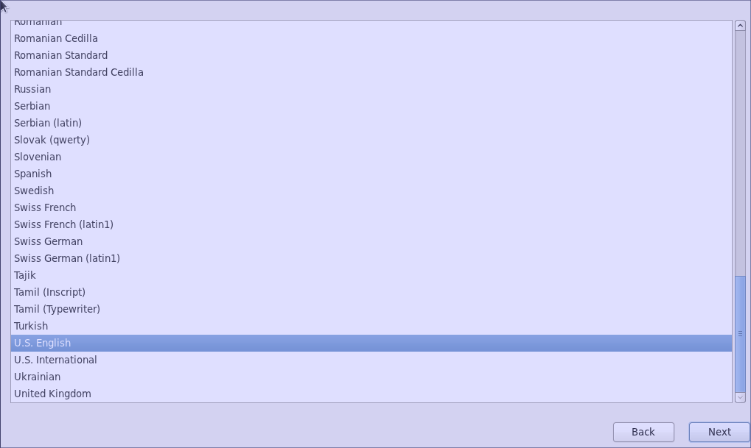

11) Choose basic storage device
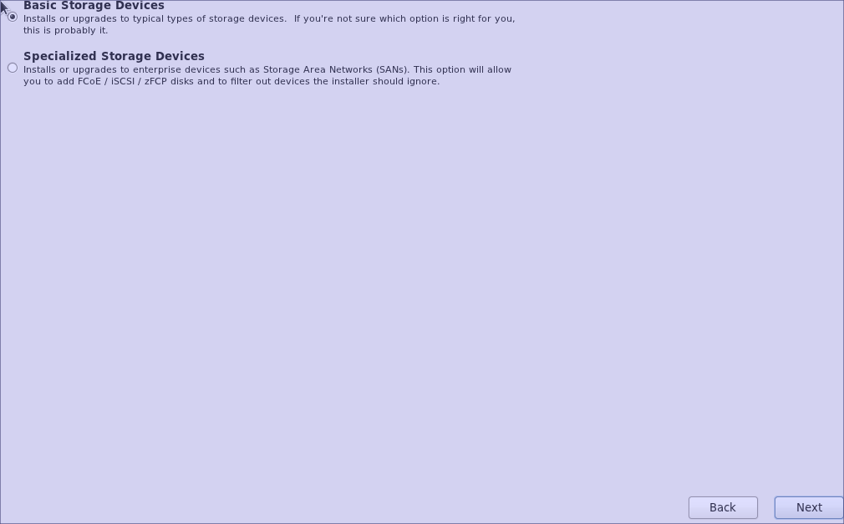

    - If you are asked to keep any data, choose yes, discard any data
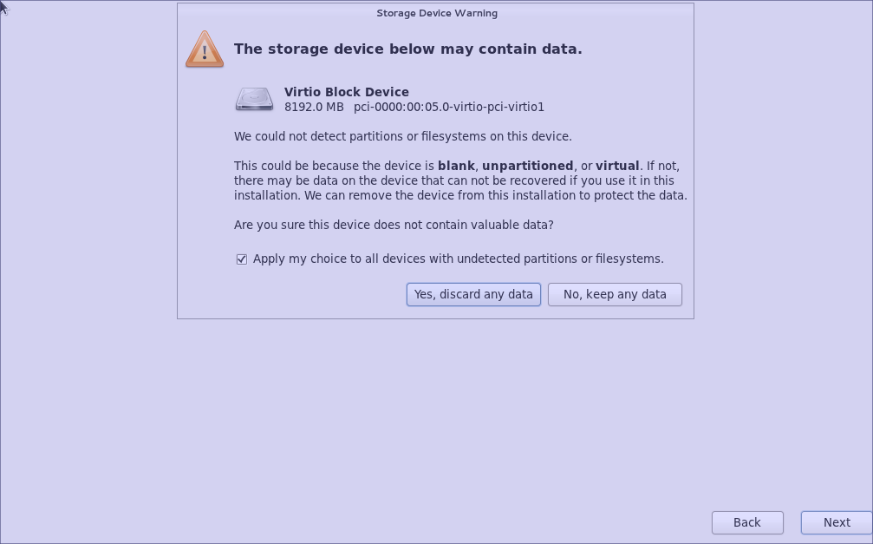

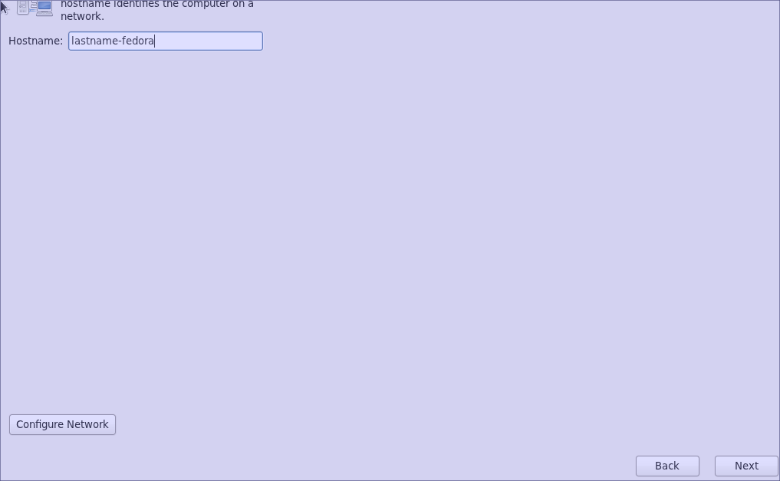
12) For the hostname, put in your lastname-Fedora, then click configure network
13) Click System Eth0 and hit edit
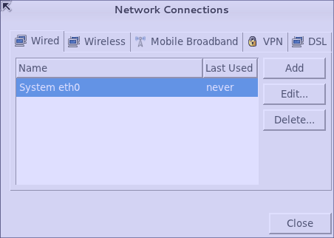

14) In the configuration menu, check connect automatically and hit save
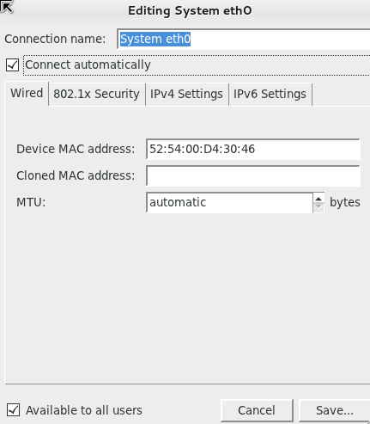

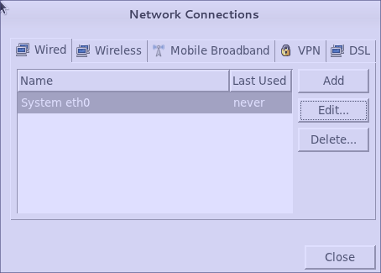
15) Hit close

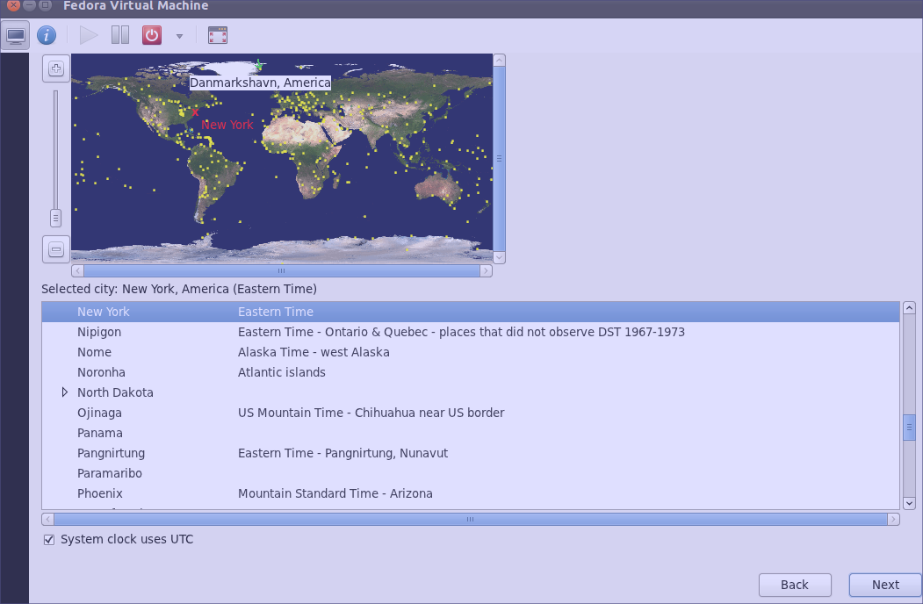
16) For the time, choose New York, Eastern Time

17) Enter the root password
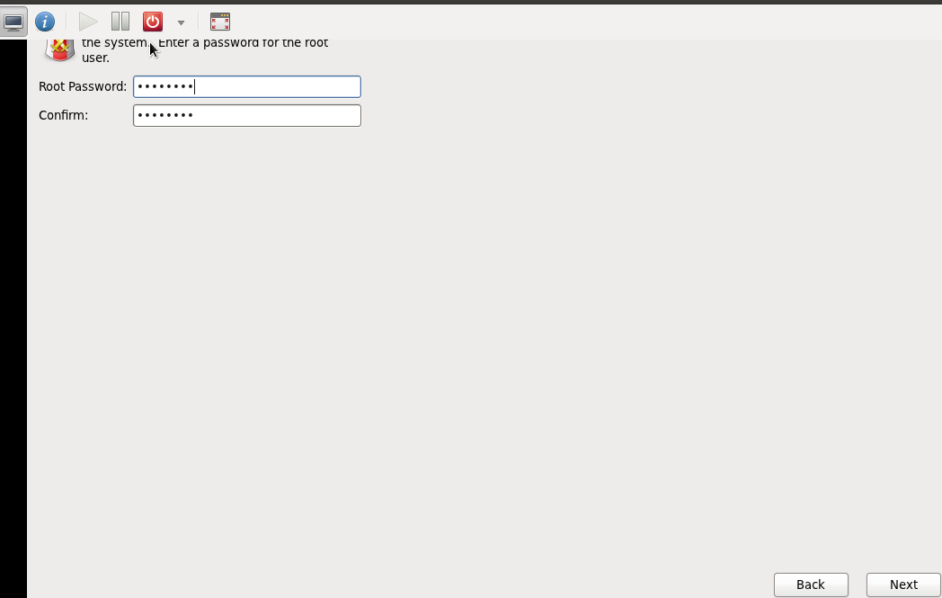

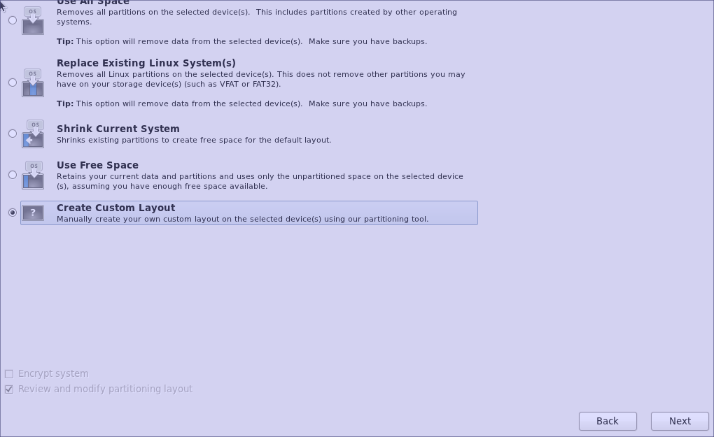
18) For the file system layout, choose Create a Custom Layout
19) Choose Free and click create
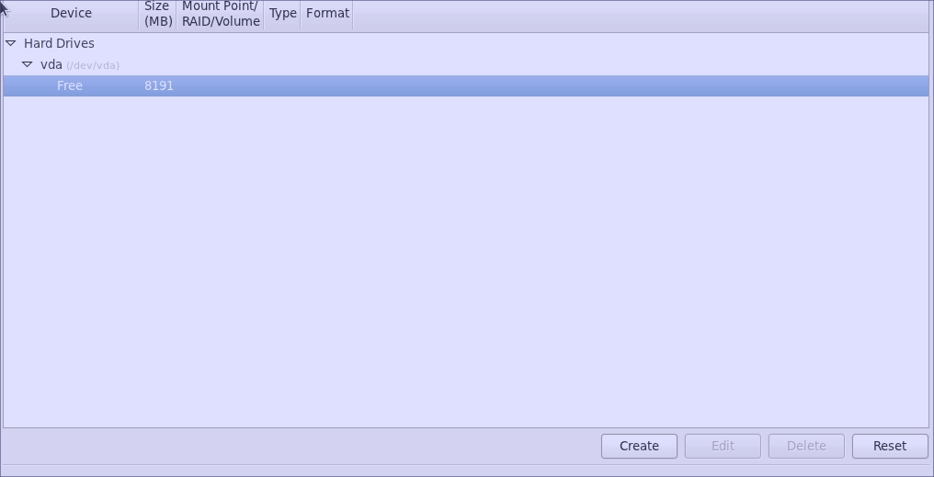
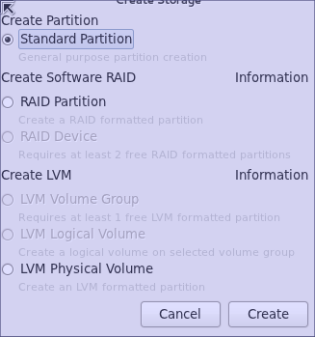
20) At the create storage screen, choose Standard Partition and click Next

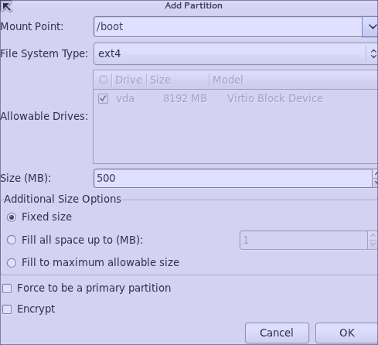
21) For the mount point, choose /boot
For File System Type, choose ext4
For size choose 500
For additional size options, choose fixed size
Hit okay

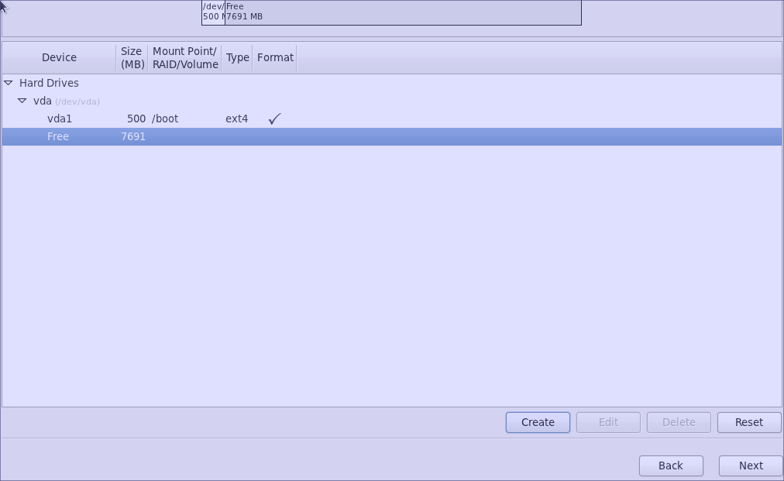
22) Choose free space again from the menu and hit create

23) Choose standard partition and hit create
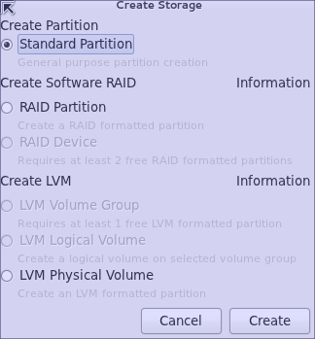

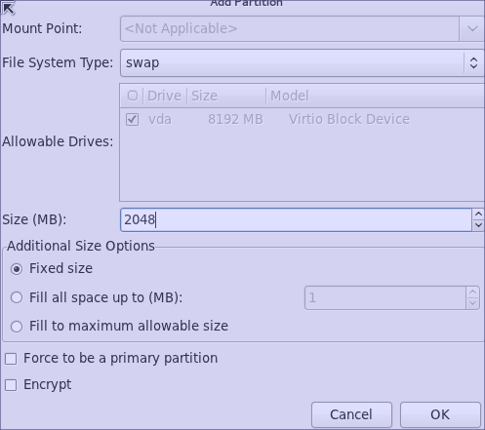
24) For File System Type, choose swap
For size choose 2048
For additional Size Options choose Fixed Size
Click OK

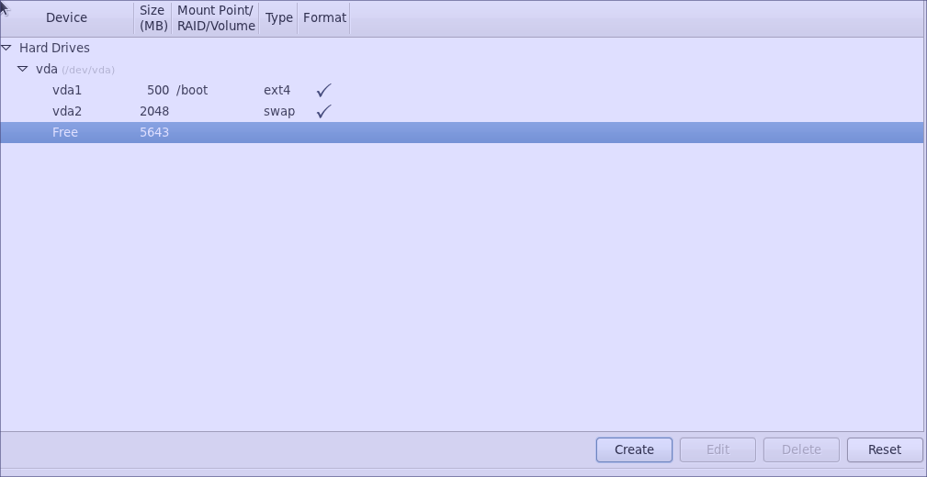
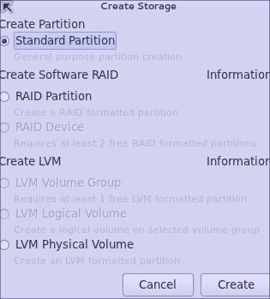
25) Again, click free space and choose create
26) Choose standard partition and hit create

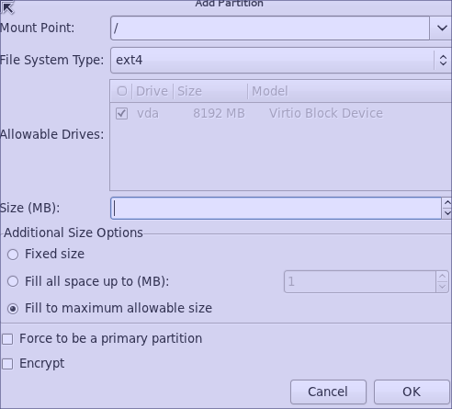
27) For mount point choose /
For file system type choose ext4
For additional size options choose fill to maximum allowable size
Choose OK

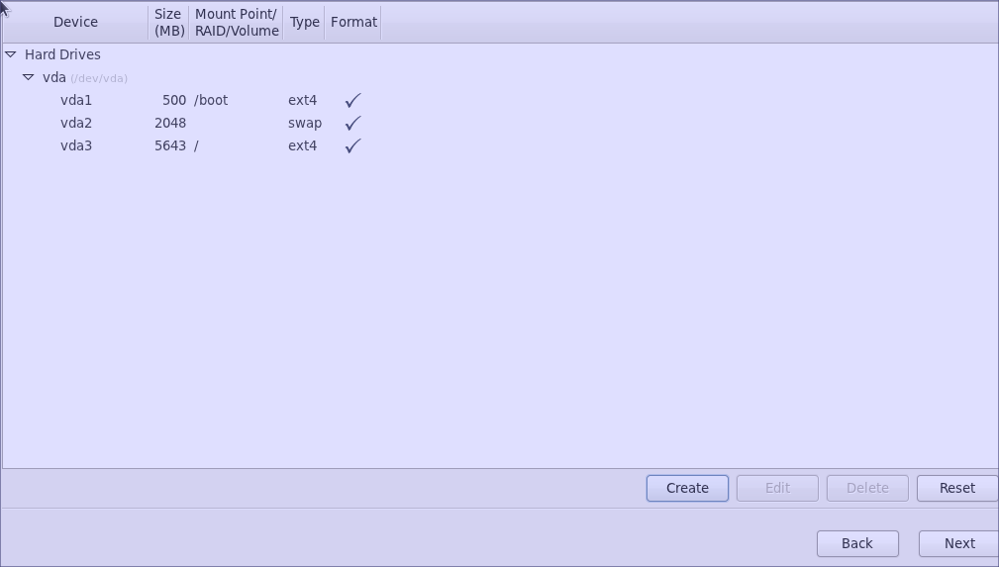
28) Hit next
29) If you get a format warning for a partition table, choose format
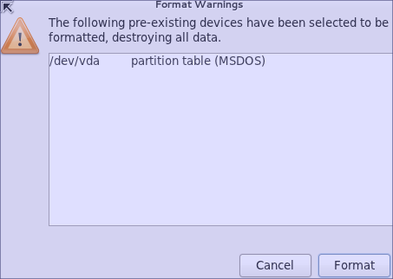
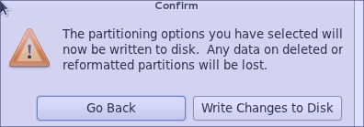
30) For the confirmation screen, choose Write changes to disk

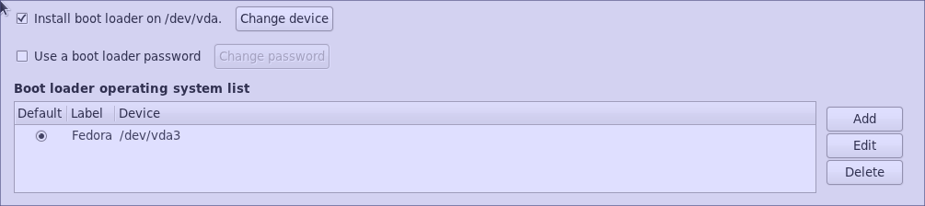
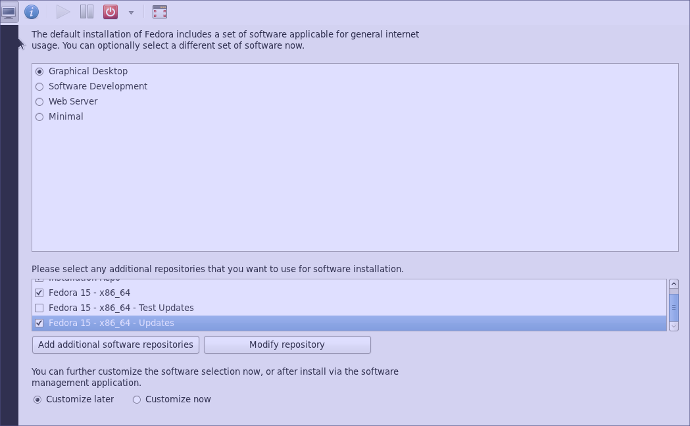
31) At the boot loader screen, choose install boot loader on /dev/vda and hit okay
32) For the environment, choose Graphical Desktop
For Customization, choose customize later
Hit next

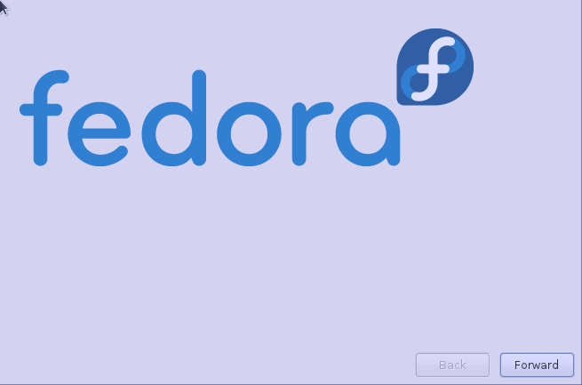
33) Allow Fedora to install and then when it is complete, reboot
34) When you restart you will be presented with a configuration menu
Hit next to begin

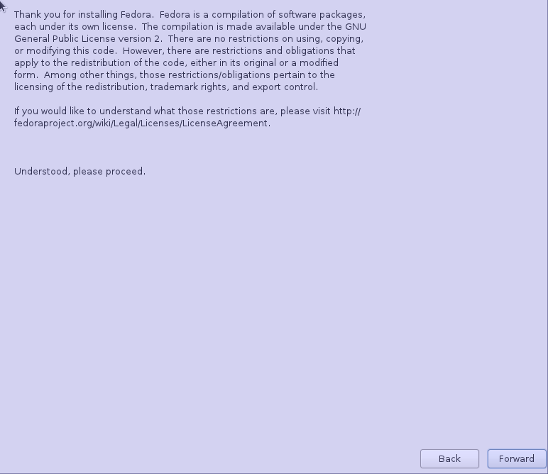
35) At the thank you screen, choose Forward

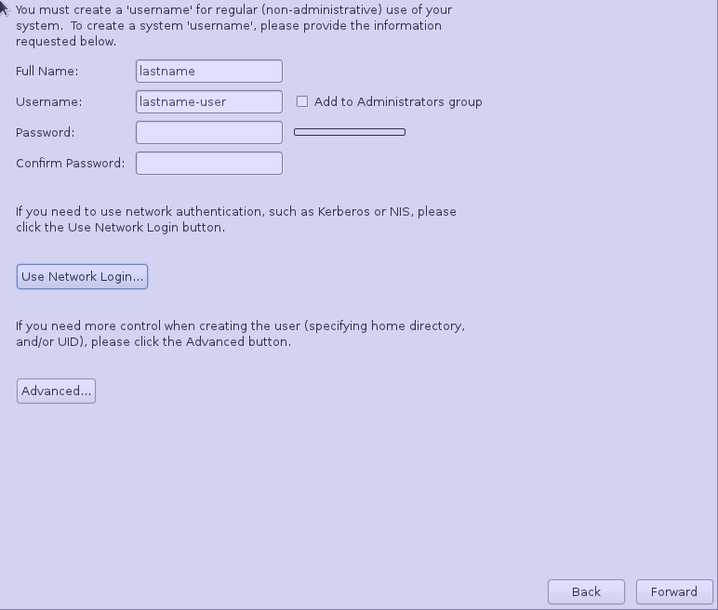
36) At the normal user creation screen type in your last name for the user
For the username, choose lastname-user
For the password, choose a password of your choosing You must remember this
Hit forward

37) Choose the correct time and date, then hit forward
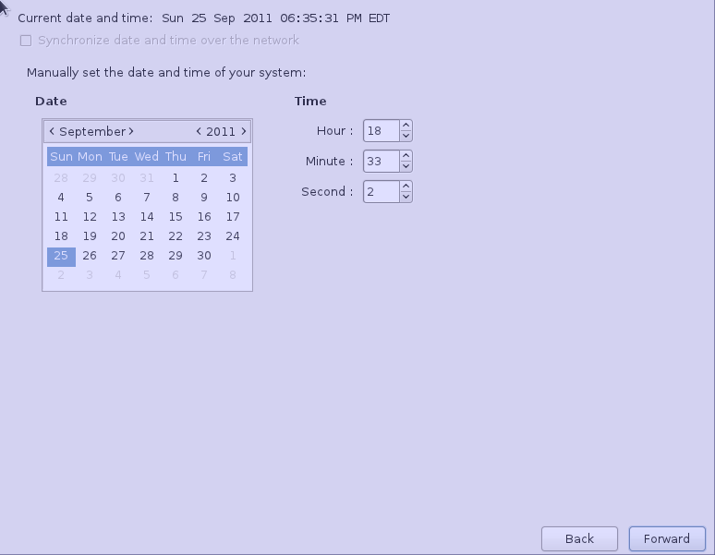
38) At the Smolt Hardware Profiler screen choose send profile and hit finish
